SAT Practice HW #1
Level 1
Name:
Date: Period: Score:

Please record all answers here.

a
b
c
d
e

a
b
c
d
e

a
b
c
d
e

a
b
c
d
e

a
b
c
d
e

a
b
c
d
e

a
b
c
d
e

a
b
c
d
e

a
b
c
d
e

a
b
c
d
e

- A band wants to distribute its music on compact discs (CDs). The equipment to produce the CDs costs $250, and blank CDs cost $5.90 for a package of 10. Which of the following represents the total cost, in dollars, to produce n CDs, where n is a multiple of 10?

  - $\left(\$250+0.59\right)n$
  - $\$250+0.59n$
  - $\left(\$250+5.90\right)n$
  - $\$250+5.90n$
  - $250n+5.90$

- A number n is increased by 8. If the cube root of that result equals -0.5, what is the value of n?

  - -15.625
  - -8.794
  - -8.125
  - -7.875
  - 421.875

- Tickets for a show cost $3 or $5. If 50 tickets were sold for a total of $230, how many tickets were sold for $3?

  - 10
  - 20
  - 25
  - 30
  - 40

- Ralph was on his way from home to work when he remembered that he left his briefcase at home. He drove home and then drove back to work. Which of the following graphs could represent his distance from home as a function of time?

  - 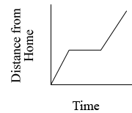
  - 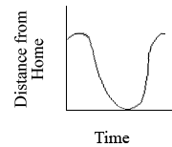

  - 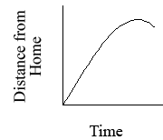
  - 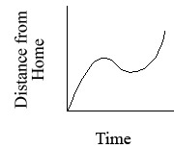

  - 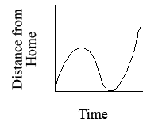

- What is the least positive integer that has the same number of positive factors as 175?

  - 8
  - 10
  - 12
  - 16
  - 18

- Twenty students have each sampled one or more of three kinds of candy bars that a school store sells. If 3 students have sampled all three kinds, and 5 have sampled exactly two kinds, how many of these students have sampled only one kind?

  - 8
  - 12
  - 15
  - 17
  - 18

- Marigolds are to be planted inside a circular flower garden so that there are 4 marigolds per square foot. The circumference of the garden is 20 feet. If marigolds are available only in packs of 6, how many packs of 6 flowers are needed?

  - 6
  - 13
  - 14
  - 20
  - 22

- The dimensions of a rectangular solid are 3 inches by 4 inches by 5 inches. The length of each edge of the solid is to be increased by 20%. What is the surface area, in square inches, of the new solid?

  - 86.4
  - 94
  - 112.8
  - 135.4
  - 162.4

- Before 1990, telephone area codes in the United States were three-digit numbers of the form XYZ. Shown above are sets X, Y, and Z from which the digits X, Y, and Z, respectively, were chosen. How many possible area codes were there?

X = 2, 3, 4, 5, 6, 7, 8, 9
Y = 0, 1
Z = 0, 1, 2, 3, 4, 5, 6, 7, 8, 9

  - 919
  - 160
  - 144
  - 126
  - 20

- The numbers 3, 5, and 7 are three consecutive odd numbers that are prime. How many other triplets of consecutive odd numbers greater than 1 consist entirely of primes?

  - None
  - One
  - Two
  - Three
  - More than 3

