Exit Slip – Hot Air Balloon

The height of a hot air balloon is a function of time. Let h(t) represent the height of the air balloon at time t. Use the graph below to answer the following questions.
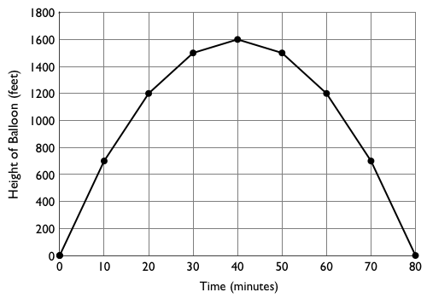

- What are the domain and range of this function?

- Find h(20) and h(70).

- Find the values of t that satisfy the equation h(t) = 1400.

- The height of the hot air balloon is modeled by the equation $h=80t-t^{2}$. Use this equation to find the height of the balloon 25 minutes after it left the ground.

