Function Applications – Volume of a Cube
s
s
s

A packaging company is designing a new line of gift boxes. They want each box to be shaped like a cube, where the side lengths are all equal. Create a function that models the
volume, V, of the box in cubic inches based on the side length, s, of the box in inches.

- Independent variable:  - Dependent variable:  - Use function notation to express the function:  - We can say ___________________________ is a  function of ____________________________.  - Write a sentence to express the meaning of the following equation. V(4) = 64  - What are the domain and range of this function?  - Describe the shape of this graph. Use the Parent Function Reference Sheet. | Complete the table below:  Graph the function on the axes below.  Scale and label the axes.  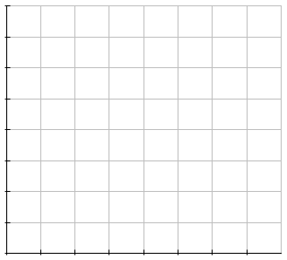
  Input  Length of Side | Output  Volume
  0
  1
  1.5
  2
  2.5

