Unit 2 – Investigation 5
Solving Literal Equations
Class Goals – By the end of the period, you will understand and be able to…
- Choose from among a variety of strategies to estimate and find values of formulas, functions, and roots.
- Simplify and solve equations and inequalities.
- Judge the reasonableness of estimations, computations, and predictions.

Example #1 The formula, $F=\frac{9}{5}C+32$, gives the temperature in degrees Fahrenheit if you know the temperature in degrees Celsius.
- What if you knew the temperature in Fahrenheit instead? It would be useful to also have a formula to find Celsius. So, what would the formula be to find the temperature in degrees Celsius if you know the temperature in Fahrenheit?

- Use the formula to find the temperature that 86° Fahrenheit would be in Celsius.

Example #2 Speaking of Fahrenheit, biologists use the formula, $n=4F-156$, to find the number of chirps per minute (n) of crickets if you know the ambient temperature in degrees Fahrenheit. Solve this equation instead for F. What does your new equation find? What would this be if the crickets chirp at a rate of about 120 chirps per minute?

- The formula for the area of a triangle is $A=\frac{1}{2}bh$. Suppose you knew the area and the height of a triangle.
  - Solve the formula for b.

  - If the Area of a triangle is 100 and the height is 20, what is the length of the base?

- An interesting geometric formula is $S=\left(n-2\right)∙180$. This formula gives you the total angle measure, S, of a regular polygon with n sides. Suppose you were Googling cool math terms online and found that the sum of the angles of a hendecagon is 1620. Unfortunately, your computer crashed before you were able to see how many sides a hendecagon has. How could you use the formula to find the answer? Briefly explain your thinking.

- The surface area of an object is the total area of its surfaces. For example, a cylinder has a top, bottom, and sides. The top and bottom are circles and the side is a rectangle when opened up. You may remember that the formula to find the surface area, S, of a cylinder is $S={2πr}^{2}+2πrh$. What if you knew the surface area and radius, but not the height? Solve the equation for h.

- Velocity associated with a constant acceleration is related to time by the equation $v=v_{0}+at$, where $v_{0}$ is the initial velocity, a is acceleration, and t is time. For example, if v₀ is 50 meters per second and a = -9.8 meters per second per second, then $v=50-9.8t$. This represents the velocity of an object thrown upward with initial velocity of 50 meters per second and being acted upon by gravity.
  - Solve the formula for t. This gives the time at which a certain velocity will occur.

  - We ordinarily think of acceleration as a constant related to the mass of the earth. Now solve the equation for a. This would allow us to calculate the acceleration caused by an object such as an unknown planet if we knew initial velocity, and the time related to a specific velocity.

- The equation A = p + prt relates the amount in your account starting with a principle amount p and adding interest at a rate r for time t.
  - Solve this literal equation for r and then t.

  - Solving for p is more of a challenge. Try it if you dare.

- The area of a rectangle can be modeled by the formula, $A=lw$.
  - Solve for l.

  - Solve for w.

  - Michael built a rectangular table that had an area of 36 ${ft}^{2}$. He can’t remember the dimensions of the table, but he knew there were no fractions or decimals. List all the possible dimensions for Michael’s table.

- The area A of an ellipse is given by the formula $A=πab$ where a and b are half the lengths of the major and minor axes. The longer chord is the major axis while the shorter chord is the minor axis.
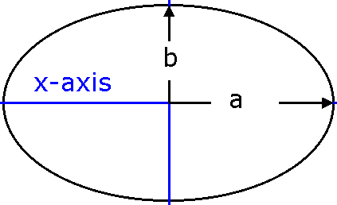

  - Solve this formula for a.

  - An elliptical serving dish has an Area that is about 157 ${in}^{2}$. If the major axis is twice minor axis, what are the dimensions of the serving dish?

