Investigation 6 – Patterns with Fractals

Class Goals – By the end of the investigation, you will understand and be able to…
- Identify, describe and analyze patterns and functions (including arithmetic and geometric sequences) from real-world contexts using tables, graphs, words and symbolic rules.
- Determine the nth term of a sequence with and without the use of technology.
- Translate one representation of a pattern into another representation.
- Write both a recursive rule and an explicit rule for a sequence.
- Make and justify predictions based on patterns.
- Make, test and describe conjectures involving properties of two- and three-dimensional figures using models.

Sierpinski’s Triangle
Sierpinski’s triangle is one of the most famous fractal designs. Below are the first three stages of the triangle. On a large equilateral triangle draw and shade Sierpinski’s triangle to extend it to Stage 3.

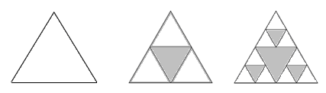
?
Stage 0 Stage 1 Stage 2 Stage 3

- Complete the chart to show the number of triangles that are unshaded in at each stage of Sierpinski’s triangle.

- Write the recursive rule to describe the number of un-shaded triangles.

- Draw and shade to complete stage 3 of Sierpinski’s Triangle.

- Now write a formula (or explicit rule) to describe the number of unshaded triangles in the n^{th} stage of Sierpinski’s triangle.

- How many unshaded triangles would be in Stage 10?

