Algebra 1 Model Curriculum (2011-12)
Cumulative Final Exam

Unit 1

Patterns
- The following octagon patterns are made up of toothpicks. One octagon takes 8 toothpicks to create, two take 15, etc.

- Make a table showing the number of the number of octagons and the number of toothpicks needed.

Number of Octagons | Number of Toothpicks
1
2
3
4
5

- Is this pattern an arithmetic or a geometric sequence?

- Write a recursive rule for this pattern.

- Write an explicit rule for this pattern.

- How many toothpicks are needed to make a row of 15 octagons? Show how you found the answer.

- You visit the Grand Canyon and drop a penny off the edge of a cliff. The distance the penny will fall is represented in the table below.

Time (seconds) | Distance (feet)
1 | 16
2 | 48
3 | 80

- How far will the penny have fallen after the 21st second?

- Write the recursive rule describing the distance the penny has fallen in relation to the time since it was dropped.

- Write the explicit rule that models the data.

- The data in the table below represents the number of rabbits that can be found in a field each year.
Year | Number of Rabbits
0 | 2
1 | 4
2 | 8
3 | 16
4 | 32

- Write the recursive rule that describes this data.

- After 7 years, how many rabbits would you expect to find?

- After how many years would it take the rabbit population to reach 50,000?

- Continue each sequence for the next three numbers. Identify if the following if the following are arithmetic, geometric or neither. If they are arithmetic or geometric write the recursive and explicit rules.

- 4, -4, 4, -4, ____ , ____, ____

Arithmetic Geometric Neither

Recursive Rule: _____________________________________

Explicit Rule: _______________________________________

- 1, 5, 9, 13, ____ , ____, ____

Arithmetic Geometric Neither

Recursive Rule: _____________________________________

Explicit Rule: _______________________________________

- 9, 10.1, 11.2, 12.3 , ____ , ____, ____

Arithmetic Geometric Neither

Recursive Rule: _____________________________________

Explicit Rule: _______________________________________

Unit 2
Equations
Solve the following equations.
1. $-6x-2x=-8$ 2. $3p+4p= -42-7$ 3. $45= -15x$

4. $115=5(3-4m)$ 5. $-6r-24=2(2-5r)$ 6. $\frac{x}{6}=6$

Evaluate each function.
7. $f\left(t\right)= t^{2}+4t$; Find $f(-2)$ 8. $h(x) = x + 3$ ; Find $h(4)$

Solve the following word problems.
9. If you can save $5.25 per week, how many weeks will it take to buy a CD that costs $15.75?

10. You are given $75 to buy juice for the school dance. Each bottle of juice costs $0.75. Write and solve an algebraic equation that models this situation.

11. Sally opened a bank account and put $500 in it. Each month, she plans on saving $40.
a. Write an equation to represent this situation.

b. Determine $f(8)$

c. Define what $f(8)$ means in the context of this problem.

d. If $f(x) = 820$, determine $x$. What does this situation represent?

12. Joe decided to open a lemonade stand. He plans on charging $0.25 per cup. He spent $20 on materials.
a. Write an equation to represent this situation

b. If Joe sells 38 cups of lemonade, how much money will he earn?

c. Joe earned a profit of $10. How many cups of lemonade did he sell?

d. How many cups of lemonade will Joe have to sell to break even?
13. Phoebe’s family wants her to do well in school. Each time she gets her report card, her dad pays her $4 for every A, and her mom pays her $5 for every A she earns. Her grandma gave her $10 at the start of the school year as encouragement plus $1 for every A she earns.
The equation $f(x) = 4x + 5x +(x + 10)$ can be used to represent the situation.

a. Determine $f(6)$

b. What does $f\left(6\right)$ mean in the context of this problem?

c. Determine how much money Phoebe will earn if she gets 5 A’s on her report card.

d. Solve the following problem: $30=4x+5x+(x+10)$

Unit 3
Functions
Vocabulary Review
- Relation: a set of ordered pairs
- Relations can be written in several ways: ordered pairs, table, graph, or mapping.
- Domain: the set of x-coordinates
- Range: the set of y-coordinates
- A function is a relation in which the members of the domain (x-values) DO NOT repeat.
- So, for every x-value there is only one y-value that corresponds to it.
- y-values can be repeated.
- Vertical Line Test (VLT): If a vertical line is passed over the graph and it intersects the graph in exactly one point, the graph represents a function.

- {(2, -6), (1, 4), (2, 4), (0,0), (1, -6), (3, 0)}
  - State the domain.
  - State the range.
  - Is the relation a function? Yes No
  - State the domain.
  - State the range.
  - Is the relation a function? Yes No

- Create a mapping of the domain and range for the following ordered pairs.
{(2, -6), (1, 4), (2, 4), (0, 0), (1, -6), (3, 0)}
Domain
Range
Is the relation a function? Yes No

- Use the vertical line test to determine if the following graphs are functions.

- Let $g\left(x\right)=-7x+4$.

  - Find $g\left(-5\right)=$

  - Find $g\left(2\right)=$

  - Find $g\left(0\right)=$

- Let $f\left(x\right)={3x}^{2}-1$

  - Find $f\left(-2\right)=$

  - Find $f\left(5\right)=$

  - Find $f\left(0\right)=$

- Predicting Grades. A student’s grade can be predicted by $g\left(x\right)={-2x}^{2}+4x+96$, where x is the number of assignments a student misses. What is the predicted grade for someone who misses 5 assignments?

- Mr. Rodrigues hired an electrician to repair some electrical work in his home. The electrician charges $80 plus $45 an hour. Let x represent the number of hours and f(x) represent the cost. Then $f\left(x\right)=45x+80$.
  - Complete the table below to determine how much Mr. Rodrigues will pay the electrician.
Cost of Hiring an Electrician
# of Hours | Cost
1
2
3
4
5
  - Evaluate f(20).

  - If Mr. Rodrigues receives a bill of $530 from the electrician, how many hours did the electrician work?

  - Plot the points on the coordinate plane. Write a title and label the axes.

Unit 4
Functions
- Write the general form of the following types of equations:
- Slope Intercept Form- ___________________________
- Standard Form- ________________________________
- Point-Slope Form- ______________________________

- What is the slope of a line that goes through the points (-2, 4) and (6, 5).

- Identify the slope and y-intercept of $y=\frac{2}{3} x-6$ Slope: ______ y-intercept: ______
- Identify the x and y-intercepts of $5x-3y=15$ x-int: ______ y-int: ______

- Graph each line. Include all key information.
  - $\frac{-3}{4}x-4$ b. $-2x+3y= -6$
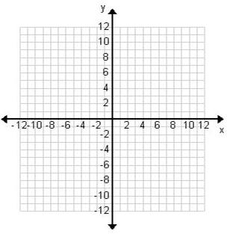

c. $y-7= -3(x+1)$

- When the Bryants leave town for a vacation, they put their dog Scruffy in a kennel. The kennel charges $15 for a first day flea-bath and $5 per day.
  - Write an equation that relates the total charge to the number of days d.

  - What is the slope of this equation?

  - How much will the Bryants have to pay if they leave Scruffy in the kennel for 3 days?

- Ms. O’Brien and Ms. Baron are going to the town fair. They have $36 to spend. They want to buy some food while they are there. Bags of popcorn cost $9 each and cotton candy costs $6 each.
  - Identify your variables

  - Write the equation for this situation.

  - Identify the x-intercept and explain what it means.

  - Identify the y-intercept and explain what it means.

- The florist told me that my new plant will grow 6.5 cm each day. I measured it on the third day and it was 31 cm tall.
  - Identify your variables

  - Write the equation for this situation.

  - Use your equation to find out how tall it will be on the 30th day.

- Given the equation $y= \frac{2}{3}x-6$

  - What is the slope of a line parallel to this line?

  - What is the slope of a line perpendicular to this line?

  - Give the equation of a line parallel to this line that goes through the point (3, -2)?

  - Give the equation of a line perpendicular to this line that goes through the point (3, -2)?

Unit 5
Scatterplots & Trend Lines
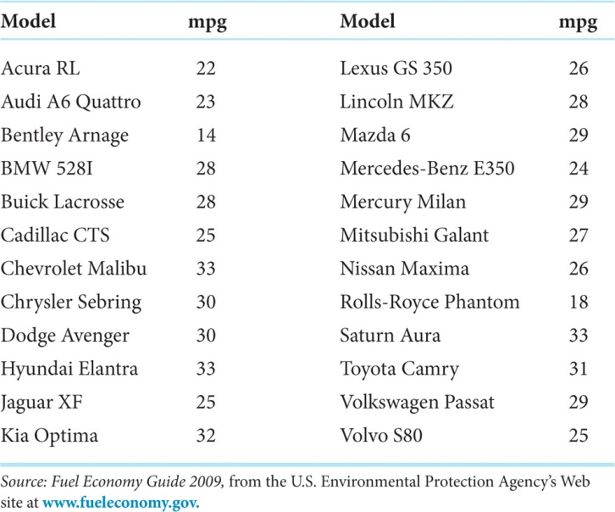
- The table to the right shows the highway model and gas mileages for midsize cars in 2009.
  - Identify the mean, median, mode of the Highway Miles per Gallon for Model Year 2009 Midsize Cars.

  - Identify the five number summary of the Highway Miles per Gallon for Model Year 2009 Midsize Cars.

  - Show your 5-number summary by creating a box-and-whiskers plot of the Highway Miles per Gallon for Model Year 2009 Midsize Cars.

  - Show if there are any outliers. (Hint: Use the IQRx1.5 Rule)

- Match of the following r values with its corresponding graph below. (Some r values will be left over.)
$r=-0.9$ $r=-0.7$ $r=-0.3$
$r=0$ $r=0.3$ $r=0.7$ $r=0.9$
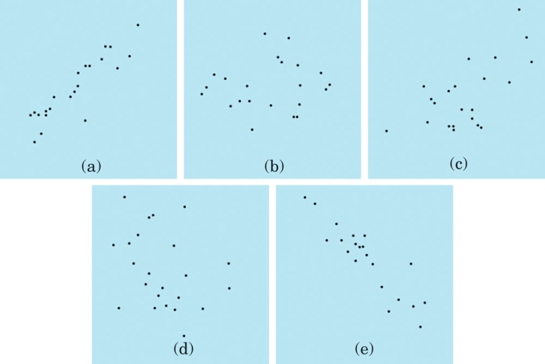

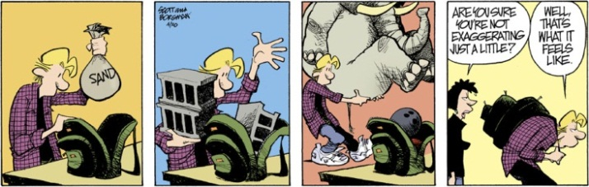
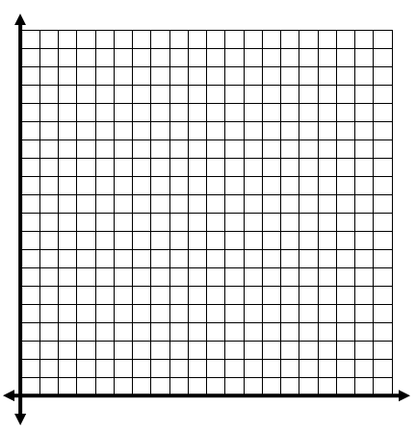
- Ninth-grade boys at Middletown High School go on a backpacking trip each fall. Students are divided into hiking groups of size 8 by selecting names from a hat. Before leaving, students and their backpacks are weighed. Here are the data from one hiking group in a recent year:

Body Weight (lb): | Backpack Weight (lb):
120 | 26
187 | 30
109 | 26
103 | 24
131 | 29
165 | 35
157 | 31
116 | 28

  - Create a scatterplot. Draw your trend line. Label your axes.
  - The Independent Variable is .

The Dependent Variable is .
  - Either using your calculator or by hand, what is the equation of your trend line?

  - The slope of your trend line is _______. What does the slope represent in the context of this situation?

  - The y-intercept of your trend line is _________. What does the y-intercept represent in the context of this situation?

  - Predict the backpack weight of a ninth grade boy that weighs 150lb.

  - Predict the weight of a ninth grade boy that has a backpack that weighs 15lb.

Unit 6
Systems of Equations
- Solve the system by graphing.
a. $\left\{\begin{aligned}y=\frac{2}{3}x+4 \\ y=-x-11\end{aligned}\right.$ b. $\left\{\begin{aligned}2x+2y=6 \\ 2x-4y=12\end{aligned}\right.$
- Solve the system by substitution.
a. $\left\{\begin{aligned}y=3x-4 \\ x+y=4\end{aligned}\right.$ b. $\left\{\begin{aligned}y=x-5 \\ y=-x-1\end{aligned}\right.$

- Solve the system by elimination (or linear combination).
a. $\left\{\begin{aligned}x+y=15 \\ x-y=11\end{aligned}\right.$ b. $\left\{\begin{aligned}2x-3y=6 \\ -x+y=10\end{aligned}\right.$

- The sum of two numbers is 200, while the difference of those two numbers is 80. What are those two numbers?

- The admission fee at a small fair is $1.50 for children and $4.00 for adults. On a certain day, 2200 people enter the fair and $5050 is collected. How many children and how many adults attended?

- The sum of two numbers is 13, while the difference of those two numbers is 3. What are the two numbers?

- Lucas and Tessa are competitive twins. Lucas has $80 saved and deposits $12 in the back each week. Tessa has $20 saved and deposits $15 each week. After how many weeks will the twins have the same amount?

- The perimeter of a fenced in yard is 220 feet. The length is 40 more than the width. What are the dimensions of the yard (Recall $P=2l+2w$)?

- The senior classes at High School A and High School B planned separate trips to the county fair. The senior class at High School A rented and filled 12 vans and 10 buses with 682 students. High School B rented and filled 5 vans and 5 buses with 330 students. Every van had the same number of students in it as did the buses. How many students can a van carry? How many students can a bus carry?

- A camp counselor needs to rent canoes and rowboats for the campers. The counselor needs 8 vessels for the kids. Canoes cost $24 each, while rowboats cost $15 each. The counselor has $165 to spend. How many of each type of boat does the counselor get?

- The temperature in Richmond is 60º and is falling at a rate of 1º per day. The temperature in Buenos Aires, Argentina is 93º and is decreasing at a rate of 2º per day. In how many days will it be the same temperature in Richmond and Buenos Aires? Adjust your window.

- A thief is running from police officers in a high-rise building. It is reported that the thief was on the 12th floor and going up the stairwell at a rate of 4 floors per minute. The police are dropped off by helicopter on the roof (which is the 174th floor) and descend through the stairwell at a rate of 2 floors per minute. In how long will it take the police to find the thief? What floor was he caught?

Unit 7
Exponential Functions
- If you invest $1500 for 16 years at 2%, how much is it worth?

- If you invest $6500 for 30 years at 4.5%, how much is it worth?

- A piece of farm equipment costs $85,000 new, but it depreciates 15% each year. Find the value of the equipment after 10 years.

- Daniel, a poker player, starts out with $200 at Mohegan Sun Casino. Each hour, he increases his bankroll by 17%. After an 18 hour session, how much does Daniel have (rounded to the nearest dollar)?

- There are initially 2000 bacteria in a culture, and the number of bacteria double each hour. The number of bacteria after t hours.
  - How many bacteria will there be in 4 hours?

  - About how many hours will it take for there to be 1,000,000 bacteria?

- In 1933, Ghandi fasted for 21 days. Afterwards, he slowly started eating again to expand his shrunken stomach. On Day 1, he started with 1 grain of rice. Each day, he tripled his rice intake.
  - How many grains of rice will Ghandi eat on Day 8?

  - How many total grains of rice did Ghandi eat during the first 8 days combined?

- The New York Jets franchise is worth $1,000,000,000 ($1 Billion USD). After a year in the new stadium, the franchise will be valued at $1,075,000,000 ($1.075 Billion USD). At this rate, how much will the franchise be worth in 5 more years?

