$\left\{\begin{aligned}y=2x+3 \\ 2x+3y=17\end{aligned}\right.$ $\left\{\begin{aligned}y=x+1 \\ 2x-y=7\end{aligned}\right.$

Solving by Substitution (2) Solving by Substitution (2)

$\left\{\begin{aligned}y=3x-7 \\ y=2x+2\end{aligned}\right.$ $\left\{\begin{aligned}x=15y+1 \\ x=3y-11\end{aligned}\right.$

Solving by Substitution (1) Solving by Substitution (1)

$\left\{\begin{aligned}-2x+5y=12 \\ 2x-y=8\end{aligned}\right.$ $\left\{\begin{aligned}-x+3y=34 \\ 5x-3y=-6\end{aligned}\right.$

Solving by Linear Combination (1) Solving by Linear Combination (1)

$\left\{\begin{aligned}y=\frac{1}{4}x-3 \\ y=2x+4\end{aligned}\right.$ $\left\{\begin{aligned}3x+4y=-24 \\ -3x+2y=6\end{aligned}\right.$

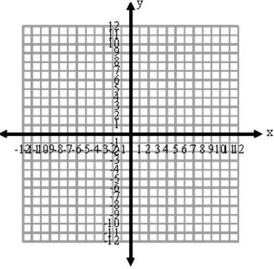
Solving by Graphing Solving by Graphing

$\left\{\begin{aligned}2x-4y=-12 \\ 5x+y=10\end{aligned}\right.$ $\left\{\begin{aligned}4x-5y=2 \\ 3x+2y=13\end{aligned}\right.$

Solving by Linear Combination (2) Solving by Linear Combination (2)

Solving Systems of Equations

